Data Aggregation Pipeline

Sergio Mateos

Southern New Hampshire University

Data Aggregation Pipeline

* Text

  Description automatically generatedLoad Data

1. Text

   Description automatically generatedCreate the database “companies”
   1. Text

      Description automatically generateddb.research.find({“name” : “AdventNet”})
   2. Text

      Description automatically generateddb.research.find({“founded_year” : 1996},{“name” : 1}.limit(10)
2. Using MongoDB queries
   1. Text

      Description automatically generatedList of the first 20 names of companies founded after the year 2010 on order alphabetically
   2. Text

      Description automatically generatedList of the first 20 names of the companies with offices in either California or Texas, ordered by the number of employee and sorted
3. Design and implement a MongoDB aggregation pipeline
   1. Match country code offices
   2. Office state code
   3. 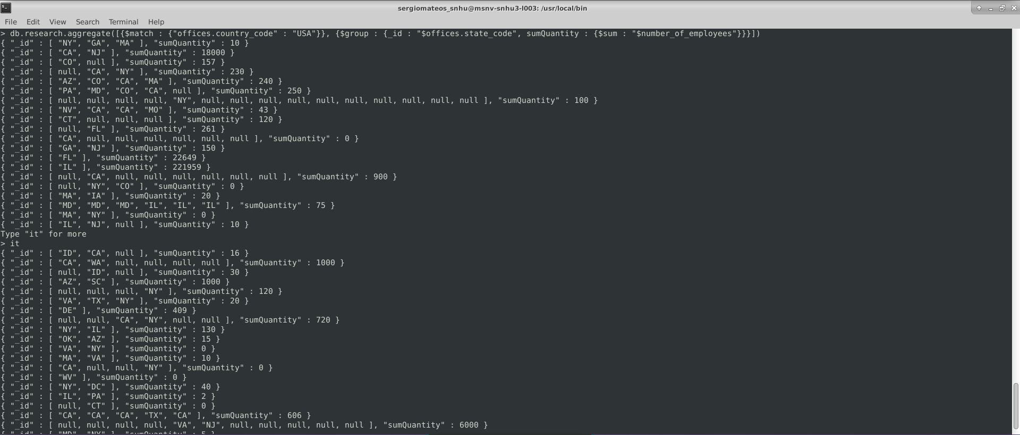Number of employees